Chapter 9, Problem 9.

Evaluate the following complex numbers and leave your results in polar form.
(a) 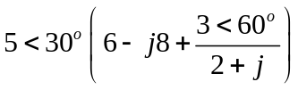
(b) 